**RED KNIGHTS MOTORCYCLE CLUB ®**

**Vermont 4**

**Chanyiah Coyle-- Secretary**

**3388 shellhouse mountain road**

**Ferrisburgh, VT, 05456**

**802-398-7945**

**E-Mail: chanyiah_lynn@outlook.com**

**TMLA File Number 04-03**

**In an attempt to have uniformity in the International Catalog PLEASE do not change colors, fonts and layout of the above header. Please follow all directions so that you item can be posted quickly.**

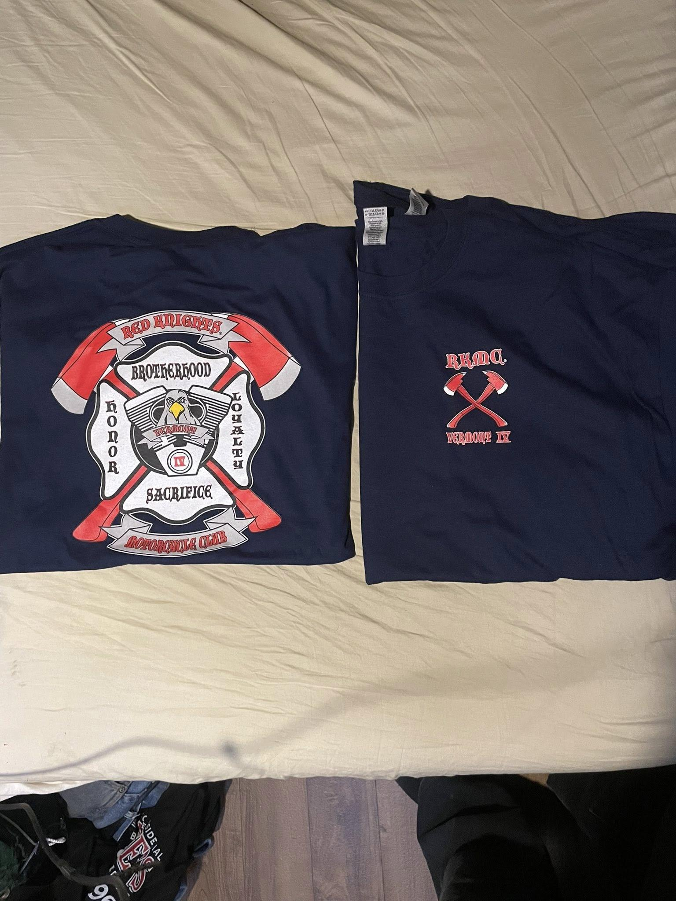

| SHIPPING: $5 for in the US and $20 for international |
| --- |

☐Automotive

☐Automotive-Misc

☐Automotive-Motorcycle

☐Coin, Patches, Pins

☐Clothing

☐Clothing-Hats

☐Clothing-Misc

☐Clothing-Vest/Vest Items

☐Clothing-Women’s

☐Decals/Stickers

☐Flags

☐Housewares-Beverage Items

☐Housewares-Misc.

☐Misc. Items

| **Item** | **Description** | **Color** | **Quantity** | **Cost ea.** | **Total** |
| --- | --- | --- | --- | --- | --- |
| **1** | Georges Shirt (SMALL) | Blue |  | $25 |  |
| **2** | Georges Shirt (MEDIUM) | Blue |  | $25 |  |
| **3** | Georges Shirt (LARGE) | Blue |  | $25 |  |
| **4** | Georges Shirt (XLARGE) | Blue |  | $25 |  |
| **Sub Total** | | | | |  |
| **Shipping and handling fees (if any)** | | | | |  |
| **Total** | | | | |  |

Please make check/money order out to **RKMC VT 4**

Please allow 6-8 weeks for delivery of items not in stock

All Prices **US currency** / Prices subject to change without notice

All items MUST be prepaid